Supporting information for Great Salt Lake Field Trip

Supplies

General Supplies (suggested)
- Spare writing utensils
- Clipboards

Geology Station

Necessary
- Magnifying devices (hand lens, microscope, or magnifying glasses)
- Two sand samples not from the Great Salt Lake (for example, coarse or fine beach sand, gravel, ideally something with rounded to angular grains)

Suggested
- Markerboard
- Folding table
- Portable microscopes and slides to place samples on

Weather Station

Necessary
- Thermometer

Suggested
- Wind meter (a hanging string may work here; wind speed gauges are available online for <$20/gauge)
- Small flag (to show relative strength and direction of the wind)

Biology Station

Necessary
Petri dishes or small clear plastic containers for brine shrimp sampling/observation

Suggested
Binoculars for birds

Density Station

Necessary
- Scales
- Graduated cylinder or other volume-measuring devices
- Water sampling container

Suggested
- Calculator
- Fluids and solids of different densities (for example, halite saturated brine, freshwater, oil, golf ball, wax)

Site Preparation Notes
Signs of life station:
- Many things (e.g., brine flies, orb-weaver spiders, and possibly brine shrimp) will not be present or less abundant in cold weather. In the fall, the first night below freezing will kill terrestrial invertibrates and brine flies.
- Even in colder weather, daddy long legs spiders might be present in between rocks and are generally pretty active
- Regardless of season, many webs will be present among rocks and near man-made structures (a sign of life even if spiders aren’t present)
- There will very likely be some remaining brine shrimp into late fall (look for small orange shrimp near shore in shallow areas, the wind will blow these to shore)
- Brine flies, if present, will be most concentrated near calm shallow pools along the lake shore
- Brine fly pupal casings are incredibly abundant along the shoreline. They will stack up in thick bands along recent high-water marks near shore. Students may not recognize these as formerly living things right away since they look like debris. These very important signs of life point to how productive the lake is.
- Point students to exposed microbial mats (stromatolites). Easy to spot when lake is low, but students may not realize what they are. There are plenty of seagulls near microbial mats, possibly other birds
Microbialite mounds: https://www.colorado.edu/lab/rockpoweredlife/research/theme-i-field-investigations/great-salt-lake
Wildlife observation:
- Swap out spider observation for bird and brine shrimp observation activities in cold weather
  - Bring binoculars for birds. Most birds will be seagulls (hoping for grebes or pelicans, but less likely). They may be tricky to observe if they are far away but will likely be near exposed stromatolites or flying overhead. If brine shrimp have recently washed ashore, this is a good place to spot feeding birds
- Bring small clear plastic containers for brine shrimp observation
  - During signs of life activity, have students collect some brine shrimp while observing what’s in the water. They will save them for this activity. Have them collect 3-4 per container if possible.
  - Brine shrimp may mate or interact with one another in containers, so this should be an interesting observation activity. You could also have students take them back to school for longer-scale observation.
Geology:
- Mirabilite (sodium sulfate mineral) mound is directly west of visitor center (see the geology station on the overview map)
  - If it is cold enough and if rain/snow does not interfere, numerous new mirabilite crystals may have formed overnight.
  - November to March is the best time of year to see these, but they may be around in remnant form at other times of the year.
  - These crystals disintegrate at warmer temperatures since they are not stable. The park discourages collecting samples from the mounds.
- As long as Oquirrh mountains are not obscured by snow/rain, old shorelines are pretty prominent on the mountainside to the south
  - You can also clearly see how far below average GSL lake level is (there are many exposed shorelines right now). Students should take note of this.

Background for leaders

Geology Section
There are at least three clear horizontal features (shorelines of Lake Bonneville) on the mountains near the park. One strong one, with a less evident one above it, one to two shorelines can be seen below the best-defined shoreline.
The sands at the Great Salt Lake are ooids. Ooids form as layers of calcium carbonate build up around a central piece of material. At the Great Salt Lake, that center is brine shrimp excrement. The ooids at the Great Salt Lake were dated using Carbon-14. The difference in age between their center and outermost layers was several thousand years!
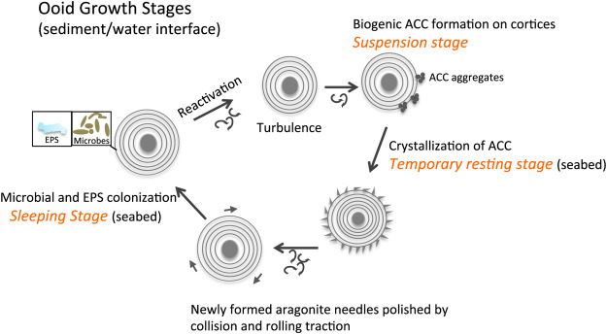
How ooids grow. Figure from: https://www.sciencedirect.com/science/article/pii/S0012825218303738
Depending on the time of year you are there (these are more common in the winter), you may see white spring mounds. These mounds are made of mirabilite. Mirabilite mounds are rare, making the ones here significant for studying geology on other planets.
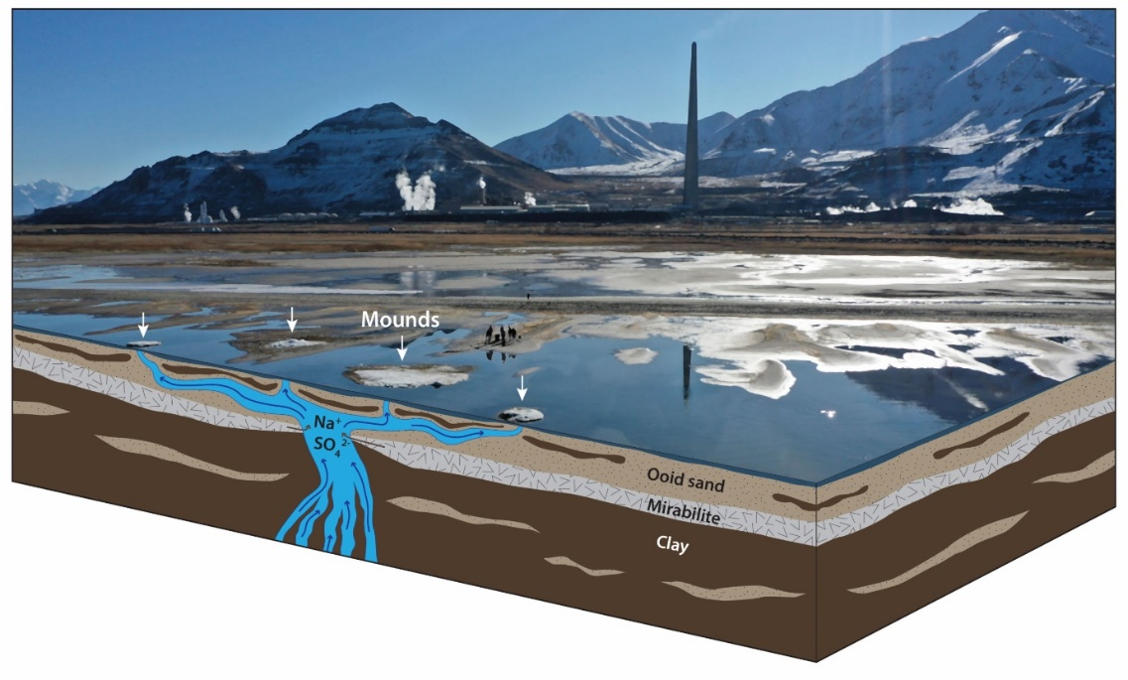
Image from: https://geology.utah.gov/interesting-facts-about-the-mirabilite-spring-mounds-near-great-salt-lake-marina/

Weather section
Great Salt Lake moderates Salt Lake Valley weather. Temperature ranges would be much more extreme (colder in the winter, hotter in the summer) without the influence of the lake. Like any large body of water, the lake holds heat for long periods. During colder months, the lake releases heat absorbed in the warmer months.
“Lake Effect” storms are notorious in the Salt Lake Valley. These storms usually develop when a cold air mass rises above the warmer Great Salt Lake. As the warmer, moisture-laden air rises, it meets with the cold air mass causing the moisture to condense and fall as heavy precipitation. Lake effect paired with a naturally intense storm can cause high precipitation levels on the Wasatch Front.
As with the ocean and other large bodies of water, water heats up more slowly than land, but it also releases heat more slowly. Water temperature remains relatively stable while the land around it fluctuates greatly. During the day, when the ground is warm, and the water is cooler, the warm air above the land rises, and the cool air above the lake moves in under the warm air on the land. This heat differential causes an inland breeze. At night the land cools off rapidly while the lake retains heat. The warm air over the lake rises, and the cool air over the land moves in under it. This reversal in heat differential results in the seaward breeze in the evening.
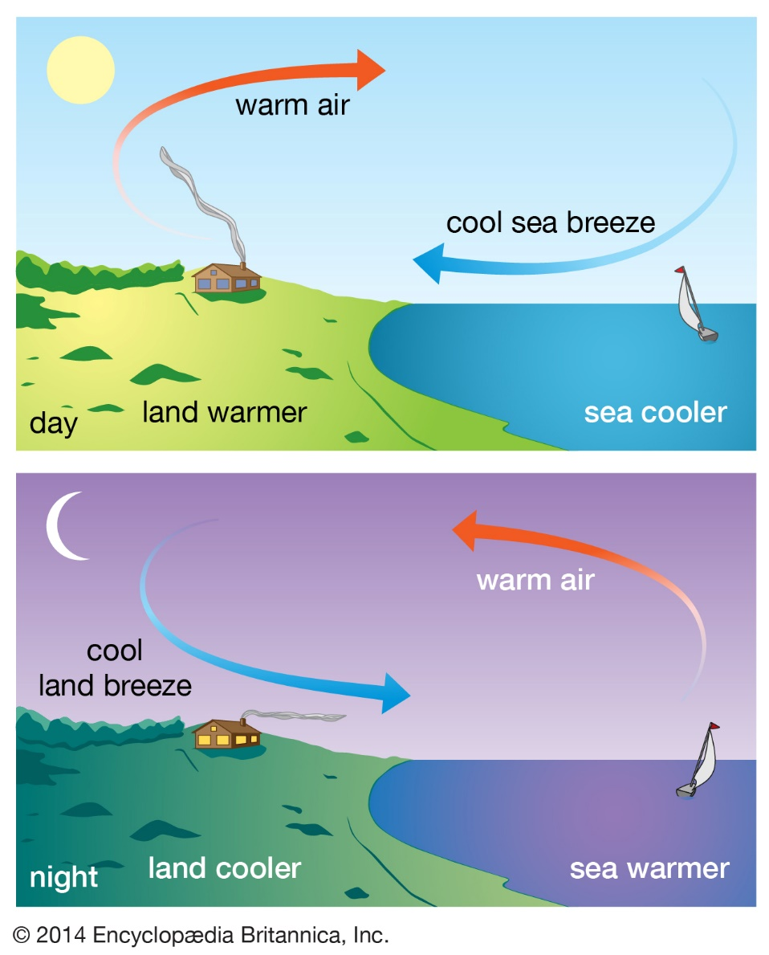
This website illustrates the effect of large water bodies on wind for the classroom: https://www.windfinder.com/#10/41.1575/-112.5357/2021-09-07T03:00Z
Depending upon your teaching plans, you can even download and use data from the weather station at the Great Salt Lake:
https://mesowest.utah.edu/cgi-bin/droman/meso_base_dyn.cgi?stn=KCC02&unit=0&time=LOCAL&product=&year1=&month1=&day1=00&hour1=00&hours=24&graph=1&past=0&order=1

Potential additional weather station questions
This chart shows the wind direction from the Great Salt Lake State Park from September 12 to 15th, 2021.
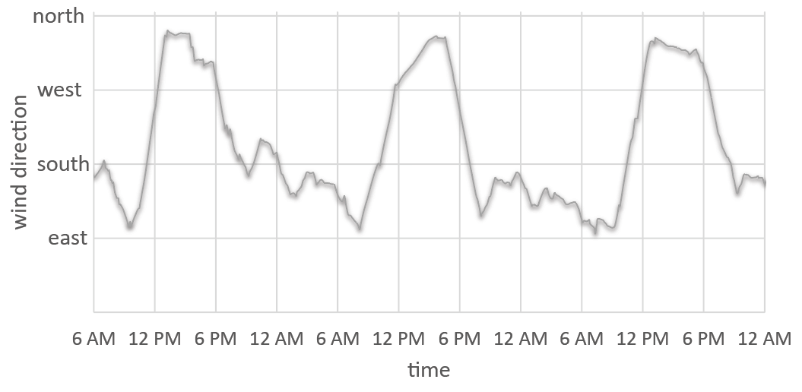
Data from MesoWest (station ID KCC02)
- What time of day does the wind blow north/northwest (towards the water)? ________________________________________________

- What time of day does the wind blow southeast (towards the land)? __________________________________________________

- Draw a diagram of temperature differences between land and water during the day. Hint: Warm air rises, causing air from cooler areas to blow in. Air moves from colder areas to warmer areas. Use this to explain the direction that wind is blowing.

- Draw a diagram of temperature differences between land and water during the night. Hint: At night the temperature of the water is warmer than the temperature of the land. Use this to explain the direction that wind is blowing.

Biology Section
The Great Salt Lake is a designated site of hemispheric importance for migratory birds. Nearly 10 million birds use the lake and surrounding wetlands during biannual migrations, and over 1 million shorebirds utilize the lake for breeding and staging areas. The Great Salt Lake ecosystem can support so many birds because of its high productivity – countless brine shrimp and brine flies living in and around the Great Salt Lake are staples in the diets of many bird species. Algae, microbial mats, and organic debris support large populations of these two primary consumers.
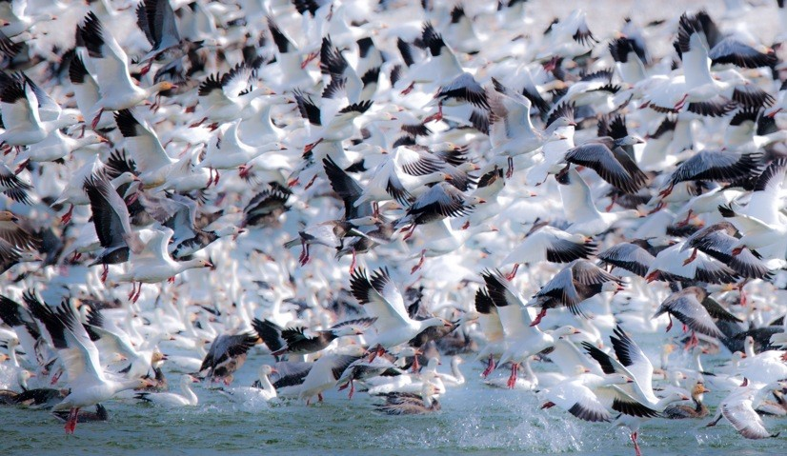
Snow geese. Credit: Gary Crandall/Friends of Great Salt Lake
Brine flies live most of their life in the water at the bottom of GSL as larvae, feeding on algae, microbial mats, and decaying organic matter. When water temperatures warm in spring and early summer, the larvae will anchor themselves to solid structures along the lake bottom. Pupal casings form around their body. Adult flies will eventually hatch from these pupal casings and float to the surface of the lake. Individual brine flies live for a relatively short time and lay eggs before they die. The eggs will soon hatch, and the life cycle begins again. Billions (literally!) of pupal casings will be washed ashore and stack up along the shoreline. Have students look closely at piles of washed-up debris along the shoreline while looking for signs of life; they are likely mostly composed of pupal casings!
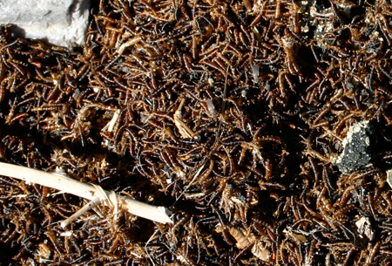
Piles of brine fly pupal casings along the GSL shoreline. Credit: University of Utah (Brine Flies (utah.edu))
Brine shrimp spend their entire lives in water. They hatch from cysts in late spring and graze on algae and organic matter within the lake. During fall, when water temperatures drop, brine shrimp mate and lay cysts. Wind can concentrate cysts into very large formations on the water's surface that almost look like red oil slicks. These cysts will stay dormant until water temperatures increase in the spring. The active brine shrimp industry on the lake harvests cysts and ships them worldwide for aquaculture purposes. From spring through fall, brine shrimp should be present in observable numbers throughout GSL and can be found in shallow water along the shoreline. Bring plastic containers for collecting brine shrimp. If students can collect multiple brine shrimp in the same container, they can observe their behavior and interactions with one another (e.g., mating).
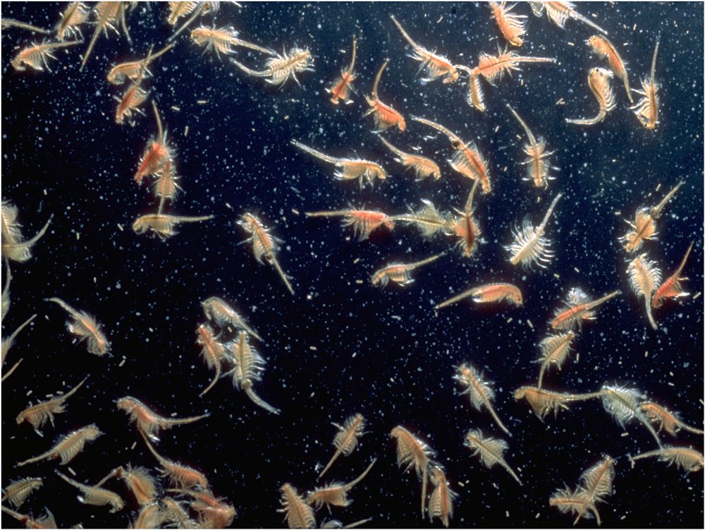
Great Salt Lake brine shrimp. Credit: Friends of Great Salt Lake
During the middle of summer, Western Spotted Orb Weaver Spiders begin to line the shoreline of GSL, preying upon the lake’s billions of brine flies. These webs creates a spectacular site along the shoreline of GSL. These large orb weavers spin very large webs in-between plants, rocks, and man-made structures along the shoreline, and often sit in the center of their webs as they wait for a meal. The orb weavers will die off as temperatures drop in fall and brine fly populations decrease. Even if orb weavers are not present (due to heavy precipitation, cold weather, or wrong season), daddy long legs spiders (which also feed on the abundance of flies) are common among rocks in this area. If spiders are not observable, webs from both species should be abundant in-between rocks and man-made structures and are important signs of life for students to note.
Late July through September is best for the orb weaver spider observation activity. Towards the end of September, there may not be many spiders left. Heavy precipitation before field trip day can also significantly impact spider observation, as it will wash spiders and their webs from structures.
If spiders are present and active, the spider observation activity (see below) is an optional addition to the field trip, and it can replace the brine shrimp or bird observation station.
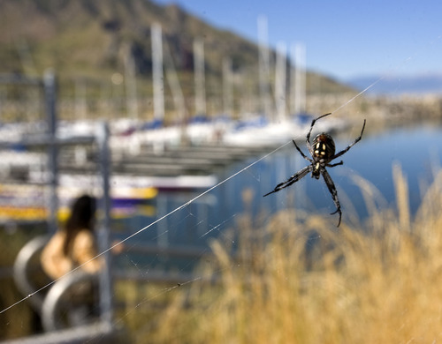
Credit: Salt Lake Tribune

Potential additional activities:
Great Salt Lake Food Web!
DIRECTIONS: Based on your observations from the previous activities, you will predict the structure of the Great Salt Lake food. Complete the food web pyramid diagram for Great Salt Lake. Think of all the animals you’ve seen around Great Salt Lake when filling out the diagram.
Secondary Consumers
Primary Producers
Primary Consumers
Tertiary Consumers
Plants, etc.
What eats herbivores?
Top of the food web: What eats secondary consumers?
Herbivores (What eats plants?)
Spider Observation
DIRECTIONS: During your signs of life scavenger hunt, you may have noticed many spiders! Now it’s time to look more closely – what are these spiders doing? In this station, you will pick one spider and watch it for 3 minutes. Keep track of what it is doing (eating, forming spider webs, moving, standing still, etc.) every 30 seconds. Record your findings in the space below!

Time | What is your spider doing?
30 seconds
1 minute
1.5 minutes
2 minutes
2.5 minutes
3 minutes

Density Section
The Great Salt Lake is a terminal or endorheic lake, meaning that the lake has no outlet. Therefore, evaporation is the primary means for water to leave the GSL basin. Dissolved solids are washed down tributaries into the Great Salt Lake where they become more concentrated due to evaporation. This causes the high salinity in GSL, which is 3 to 5 times more saline than seawater. Due to this high salinity, Great Salt Lake's water is quite dense compared to freshwater or seawater. GSL water density often ranges from 1.08-1.18 kg/L (g/cm⁻³), while seawater and freshwater typically have densities of 1.03 and 1.00 kg/L (g/cm⁻³, respectively. This is an easily observable/measurable difference for students.

Additional Resources
General resources:
https://westminstercollege.edu/student-life/great-salt-lake-institute/great-salt-lake-teacher-resources.html
https://site.utah.gov/stateparks/wp-content/uploads/sites/13/2015/02/GSL-Ed-packet1.pdf
https://learn.genetics.utah.edu/content/gsl/
Biological resources:
https://westminstercollege.edu/_resources/files/default-source/great-salt-lake-institute/great-salt-lake-institute/teacher-professional-development/studying-the-great-salt-lake/great-salt-lake-fie/lakeside-learning.pdf
https://westminstercollege.edu/_resources/files/default-source/great-salt-lake-institute/great-salt-lake-institute/teacher-professional-development/studying-the-great-salt-lake/gsl-bioaccumulation-game5eee.pdf

